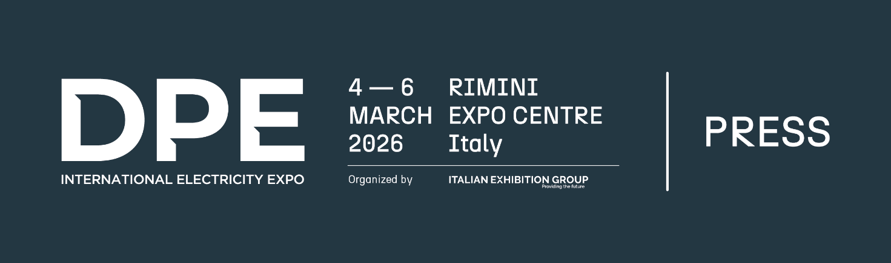

press release

DPE – INTERNATIONAL ELECTRICITY EXPO 2026
ACCELERATES THE ELECTRIC SYSTEM TRANSFORMATION

- New edition of the electrical generation, transmission, distribution, safety and automation ecosystem event, from 4th to 6th March at Rimini Expo Centre, in conjunction with KEY – The Energy Transition Expo.
- Organised by Italian Exhibition Group in collaboration with Generazione Distributa – Engines, Components and Generating Sets, a confederate of ANIMA Confindustria, and ANIE Federation

Rimini, 24th February 2026 – The development of renewables and energy transition acceleration are redefining global energy balances. The way in which energy is produced, distributed and used, and how its continuity is guaranteed, is changing rapidly and the integration of non-programmable sources, ever-increasing digitalisation, the need to optimize flows to guarantee network flexibility and security of supply, all make rapid infrastructural and technological adaptation of the electricity system increasingly urgent.

To give space to this rapidly expanding sector, and consolidating Italy's role as a technological energy transition hub, a new edition of DPE - International Electricity Expo, the event specifically for the electrical generation, transmission, distribution, safety and automation ecosystem, will be back at Rimini Expo Centre from 4th to 6th March. The event is organised by the Italian Exhibition Group in collaboration with Generazione Distributa – Engines, Components, Generating Sets, a confederate of ANIMA Confindustria - and the ANIE Federation – which, as part of the Confindustria System, represents electrotechnics and electronics supply chain companies and general industrial contractors.

The event will take place in conjunction with KEY - The Energy Transition Expo, enhancing the close link between distributed generation and renewable sources and involving the entire supply chain of solutions and technologies to support the green transition. A complete and integrated context that ranges from sustainable energy production to its transport and distribution.

DPE 2026 will provide an opportunity for discussion, networking, know-how exchange, and advanced solution discovery, also through highly qualified content, events and workshops, so that companies will be able to transform current challenges into innovation opportunities, thus strengthening their competitiveness on the market.
These events will include ENERGY INFRASTRUCTURE FOR GROWTH - Prospects, enabling technologies, critical issues, organised by ANIE and Generazione Distribuita, scheduled for Thursday 5th March at 4.15 pm in the Energy Distribution Arena (hall A5).

The event will also be the ideal stage to showcase national and European excellence in the electrical hardware sector with an exhibition that ranges from generator sets to industrial engines, light towers, static and dynamic UPSs, alternators and transformers, as well as storage, conversion and power factor correction systems, control panels, LV and MV equipment and switchboards. Cables and distribution systems will also be on display together with mechanical, electrical and electronic components, and companies offering engineering and technical consultancy services will be attending. As will Designers, installers, electrical material distributors, O&M, Utilities, EPC Contractors, ESCos, maintenance workers and rental companies.

“The integration of non-programmable renewable sources, the diffusion of storage systems and consumption electrification increasingly need electricity networks to evolve towards intelligent, digitalised and resilient models”, says Alessandra Astolfi, Global Exhibition Director of Italian Exhibition Group’s Green & Technology Division. "DPE gives this dimension centrality by enhancing the entire electrical hardware supply chain and solutions for energy generation and management. Moreover, being in conjunction with KEY is strategic and further strengthens this approach. Indeed, the two events represent a single ecosystem that allows us to offer the market an integrated vision of all the solutions available to make the energy transition concrete and achievable.”

“The Energy Transition is unimaginable without modern and efficient electricity infrastructure,” says Giorgio Paris, President of Generazione Distributa. "In fact, the entire paradigm of change hinges on the growing use of electricity as an electrical vector in both industry and the residential sector as well as mobility. This edition of DPE will not only showcase the entire Italian and European electrical hardware industry, but will also put the theme of distributed generation at the centre of the debate as an essential element in the energy transition process, guaranteeing the operational continuity of the production system and protecting vital infrastructures."

““In recent years the global energy system has undertaken an unprecedented structural transformation, driven by decarbonisation, consumption electrification, and infrastructure digitalisation,” says Michele Lignola, General Director of the ANIE Federation. "In this scenario, distributed generation, intelligent networks and advanced electrical technologies play a decisive role in guaranteeing the security, resilience and flexibility of the electricity system, while enabling the integration of renewable sources. The companies represented by ANIE are among the key players in this evolution and provide the technologies that enable electrification, automation, digitalisation and energy efficiency. In this context, DPE confirms its role as a reference event for the entire electricity supply chain: a place of discussion where industry and market can share concrete solutions to accelerate the energy transition and strengthen the competitiveness of our production system.”

ABOUT DPE - International Electricity Expo
Event: European trade show; Organisation: Italian Exhibition Group S.p.A.; Edition: 3rd; Dates: 4-6 March 2026; Website: www.dpeurope.it; LinkedIn: www.linkedin.com/dpe---distributed-power-europe/

PRESS CONTACT KEY - ITALIAN EXHIBITION GROUP
head of media & corporate communication: Elisabetta Vitali; press office manager: Marco Forcellini, Pier Francesco Bellini; international press office coordinator: Silvia Giorgi; press office coordinator: Luca Paganin; press office specialists: Nicoletta Evangelisti, Mirko Malgieri; media@iegexpo.it

MEDIA AGENCY: Smartitaly Communications
Sara Scatena, s.scatena@smartitaly.it, mob. +39 338 7836985; Francesca Pericolo, f.pericolo@smartitaly.it, mob. +39 327 986 1860

